New Press
Information

April 12th, 2018
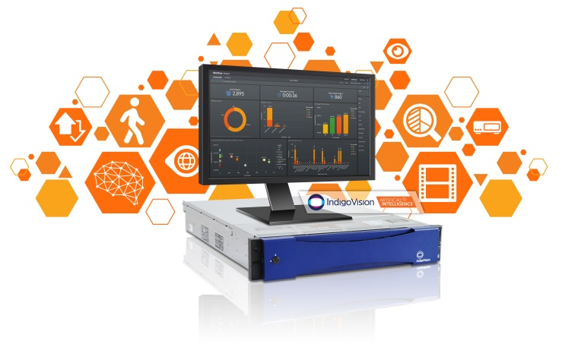
Photo Caption: Artificial Intelligence powered by BriefCam.

IndigoVision’s Artificial Intelligence expanding to include latest security features.

IndigoVision – leading developer of complete end-to-end video security solutions – today announced that the next release of their Artificial Intelligence powered by BriefCam will include the latest security features in the industry, and will be launched within the coming weeks, additional to it being previewed at ISC West 2018 in Las Vegas.

IndigoVision’s Artificial Intelligence powered by BriefCam allows IndigoVision customers to quickly and easily review hours of footage in minutes, rapidly identifying people and objects of interest by object type, attribute, direction, color or size.

The recently announced BriefCam v5 introduces new capabilities across all three of the platform’s seamlessly integrated modules, delivering a powerful approach to making video searchable, actionable and quantifiable. The new version enables customers to rapidly realize both the security and business value their surveillance system can provide by innovatively harnessing the process-once-use-many paradigm throughout the platform. These new features and capabilities are directly aligned with IndigoVision’s offering, providing customers with statistical analysis reports, business intelligence insights, as well as multi-camera search and facial recognition. The user interface is also now entirely browser-based, allowing operators to connect without the need to install any software on their machines.

Commenting on this development IndigoVision’s Software Product Manager, Giles Raine, said “I’m delighted that IndigoVision’s technology partnership with BriefCam means that we are on the leading edge of Artificial Intelligence in the Security industry, providing IndigoVision customers with the most powerful analytics that use deep learning technology to convert raw video into quantitative, actionable insights.”

IndigoVision’s technology partnership with BriefCam began in early 2017, providing IndigoVision customers with a new era of security intelligence. The continual development of Artificial Intelligence is aligned with IndigoVision’s strategic goal of providing their customers with innovative solutions that make them safe.

For more information on IndigoVision’s Artificial Intelligence powered by BriefCam please contact IndigoVision at www.indigovision.com/contact-us/.

About IndigoVision
IndigoVision provides a complete video security solution where performance and stability go hand-in-hand. All of our products are single-mindedly designed towards enhancing your security. The purpose of a security system is to make you safe and feel safe. That includes your person, business, property and budget. We design your system end-to-end, with no single point of failure, so it's reliable. We design it with Distributed Network Architecture so it's flexible. You can add any number of cameras and workstations effortlessly. We make it smart, so your old analog cameras will migrate to IP and work with our HD cameras. You can integrate other HD cameras where and when you need them or other manufacturers' security systems using our Software Development Kit, such as Access Control, Communication Systems and Perimeter Detection. When you choose an IndigoVision system you are future-proofed: the cameras you buy today we will still support for years to come. Our global support team back it all up so your problem is our problem. That's when you discover that safe is a wonderful feeling.

For further information contact IndigoVision:
Americas - Tel: +1 732 662 6445, Fax: +1 732 909 2658
UK and Rest of World - Tel: +44 131 475 7200, Fax: +44 131 475 7201
E-mail press@indigovision.com or visit www.indigovision.com

