New Press
Information

February 8th 2019

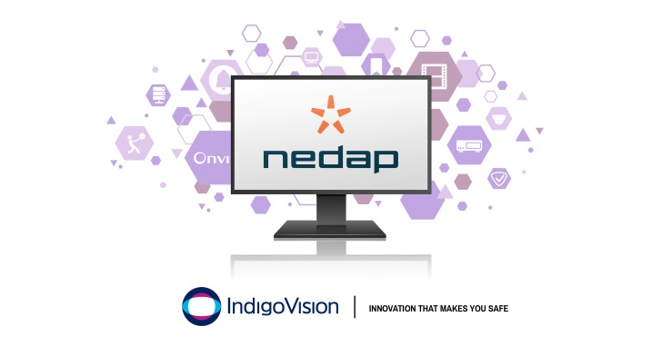
IndigoVision are excited to release a new Access Control Integration with Nedap

The new IndigoVision Nedap AEOS Integration allows events from Nedap AEOS systems to be seamlessly combined with IndigoVision’s security management solution, Control Center, giving complete video and alarm management in a single user interface.

All of IndigoVision’s Integrations are designed with your security in mind and the Nedap AEOS Integration is no different. Since 1980, Nedap has been a leader in the design and manufacture of electronic access control systems. With the new IndigoVision Nedap AEOS Integration, you can trigger live video, move PTZ cameras, start recordings and send notification emails automatically, helping to dramatically decrease operator response time.

Events from Nedap AEOS can be forwarded to Control Center allowing operators to respond to incidents from a single interface. Examples of supported Nedap AEOS events are, direct door alarm, door manual unlock, door open too long and badge no access events.

Commenting on the Nedap AEOS Integration, IndigoVision’s Software Product Manager Giles Raine said, “Nedap’s AEOS access control is clearly growing rapidly in the marketplace, there’s a lot of positive buzz about it - so it’s great to be adding this integration to our portfolio. Nedap themselves have been outstanding in their support during our development of the integration, making them a pleasure to do business with.”

IndigoVision’s Nedap AEOS Integration is not only designed towards enhancing your security but also to give you the flexibility and choice to create a custom security management solution that works for you. When you use any one of IndigoVision’s Integrations you can be sure that you won’t be let down.

To find out more about this release and the rest of IndigoVision’s innovative end-to-end security solution please visit www.indigovision.com

END
About IndigoVision
IndigoVision has more than two decades of experience developing innovative, complete, end-to-end security surveillance solutions. We provide a complete video security solution where performance and stability go hand-in-hand. All of our products are single-mindedly designed towards enhancing your security and are trusted and proven globally, across multiple markets, in some of the highest profile sites and harshest environments.
Our unique Distributed Network Architecture (DNA) removes the need for a central server, resulting in no single point of failure You can add any number of cameras and workstations effortlessly. We make it smart, so your old analogue cameras will migrate to IP and work with our HD cameras.
Founded in 1994 Edinburgh, Scotland, upholding a truly global presence, our global technical support teams make your problem OUR problem. IndigoVision give you the right solution, experience, technology and support to provide you with the innovation that makes you safe.

