New Press
Information

January 17th 2019

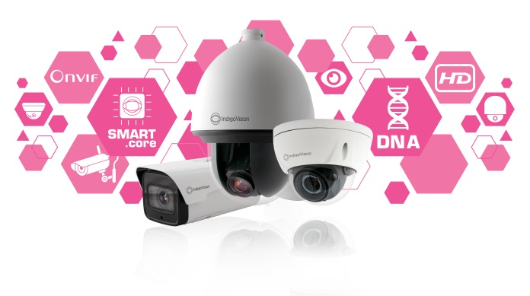

Photo Caption: Introducing the NEW HD Ultra Camera Range... Superior functionality, performance and innovation

Introducing the NEW HD Ultra Camera Range... Superior functionality, performance and innovation

With 25 years of experience developing innovative, complete, end-to-end security surveillance solutions, IndigoVision are excited to introduce our new HD Ultra Camera Range where you’ll find superior functionality, performance and innovation. The new HD Ultra Camera range will be on display at Intersec 2019 in Dubai, giving attendees the first look at the product range.

Claiming the title of the most advanced camera release to date this exciting new HD Ultra Camera Range knows exactly what it is talking about when it comes to security, available in three stylish form factors the HD Minidome, HD Bullet and an HD PTZ Pendant. All with built-in SMART.core™ technology, CyberVigilant® in Camera, and with Advanced Analytics. These cameras are designed to offer superior functionality, performance and innovation.

Embedded into the heart of the cameras IndigoVision’s SMART.core™ technology includes better audio and low light performance, optimized H.264 compression, Activity Controlled Framerate Plus (ACF+) and it ensures lower bandwidth and storage requirements saving you money in the long term.

As well as being smart these cameras take cyber-security seriously with IndigoVision’s unique and innovative cyber-security technology CyberVigilant® in Camera being on board. With an extra layer of defence through an enhanced firewall, customers receive notifications direct to their Control Center user interface in the event that a cyber-attack takes place.

Advanced analytics such as Motion Detection, Tamper, Tripwire, Intrusion, Scene Change and Missing or Abandoned Object are also built-in the camera range, helping to enhance customers’ security.

Additional to these incredible features the new HD Ultra Cameras are also compatible with the latest version of IndigoVision’s Security Management Solution, Control Center v15.4. This powerful software includes new improvements such as automatic notification of NVR License faults, new Dynamic Profile Switching mode and VPN for Integra®.

These fantastic features combined with our commitment to open standards, integration and unique Distributed Network Architecture are what makes IndigoVision an industry leader within the security sector.

Installed in over 15,000 installations globally, IndigoVision products are trusted and proven across multiple markets, in some of the highest profile sites and harshest environments. All of our products are single-mindedly designed towards enhancing your security and our HD Ultra Camera Range is no different.

For more information on IndigoVision’s new HD Ultra Camera Range and the rest of our end-to-end security solution please visit: www.indigovision.com.
ENDS

About IndigoVision

IndigoVision has more than two decades of experience developing innovative, complete, end-to-end security surveillance solutions. We provide a complete video security solution where performance and stability go hand-in-hand. All of our products are single-mindedly designed towards enhancing your security and are trusted and proven globally, across multiple markets, in some of the highest profile sites and harshest environments.

Our unique Distributed Network Architecture (DNA) removes the need for a central server, resulting in no single point of failure. You can add any number of cameras and workstations effortlessly. We make it smart, so your old analogue cameras will migrate to IP and work with our HD cameras.

Founded in 1994 Edinburgh, Scotland, upholding a truly global presence, our global technical support teams make your problem OUR problem. IndigoVision give you the right solution, experience, technology and support to provide you with the innovation that makes you safe.

