New Press
Information

October 30th 2018
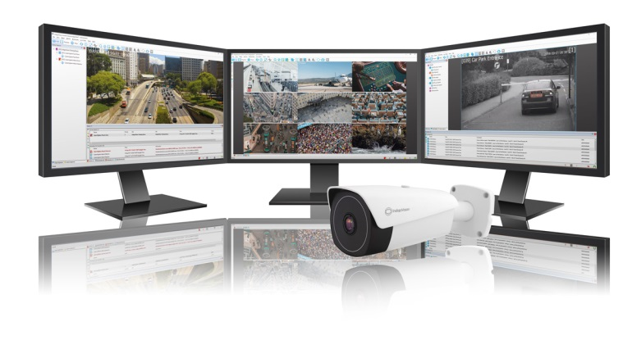
Photo Caption: Detect. Deter. Disrupt.
Detect. Deter. Disrupt. Introducing the latest innovative products from IndigoVision!

IndigoVision, leading developer of complete end-to-end IP video security solutions, released new innovative products during GSX 2018 and Security Essen 2018 this year that allows customers to further enhance their security solution.

IndigoVision’s latest version of their tiered Security Management Solution, Control Center v15.3, will help to enhance your security system with exciting improvements to the CyberVigilant® device (including Alarm Collapsing features), Reorder Storyboard Clips and the introduction of the Federated License Server.

IndigoVision’s intelligent and accurate License Plate Recognition (LPR) is powered by InnoWare and takes your system beyond traditional License Plate Recognition. Integrated into IndigoVision Control Center, LPR powered by InnoWare is ideal for stop and go applications, such as parking-lot access where cards or money are required to enter and exit. This technology can also be used for free flowing traffic at speeds of up to 200km per hour and is able to read plates with a very high level of accuracy.

IndigoVision’s BX Thermal Bullet Camera has been updated to deliver a different dimension of safety. This update includes a higher frame rate of 30fps, a new sensor update, audio input & output, fire detection analysis and CyberVigilant® in Camera, making it the perfect solution for dark, long range monitoring applications.

For over 20 years, IndigoVision have been on the forefront of cutting edge technology and innovation in the IP security industry. Trusted in more than 15,000 installations, IndigoVision can be relied upon to provide you with innovation that makes you safe.

For more information on IndigoVision, Control Center v15.3, IndigoVision’s LPR powered by InnoWare technology, BX Thermal Bullet Camera and the rest of our end-to-end security solution please visit: www.indigovision.com.
ENDS

About IndigoVision

IndigoVision has more than two decades of experience developing innovative, complete, end-to-end security surveillance solutions. We provide a complete video security solution where performance and stability go hand-in-hand. All of our products are single-mindedly designed towards enhancing your security and are trusted and proven globally, across multiple markets, in some of the highest profile sites and harshest environments.

Our unique Distributed Network Architecture (DNA) removes the need for a central server, resulting in no single point of failure You can add any number of cameras and workstations effortlessly. We make it smart, so your old analogue cameras will migrate to IP and work with our HD cameras.

Founded in 1994 Edinburgh, Scotland, upholding a truly global presence, our global technical support teams make your problem OUR problem. IndigoVision give you the right solution, experience, technology and support to provide you with the innovation that makes you safe.

