New Press
Information

October 30th 2018
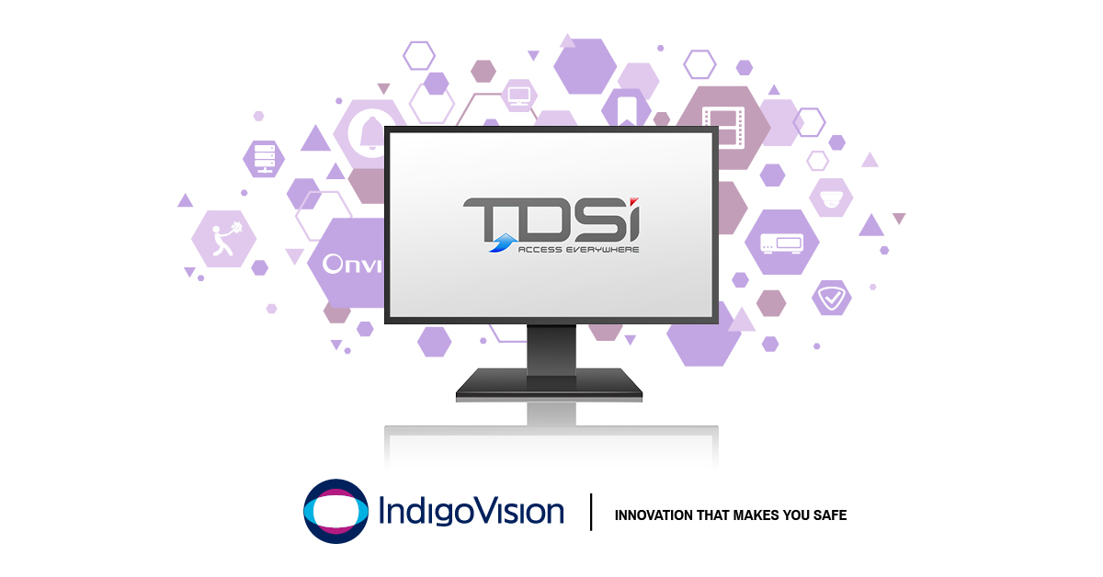

IndigoVision and TDSi are excited to introduce a brand new Access Control Integration
The new IndigoVision TDSi EXgarde Integration allows alarms from TDSi systems to be seamlessly combined with IndigoVision’s security management solution, Control Center, giving complete video and alarm management in a single user interface.
All of IndigoVision’s Integrations are designed with your safety in mind and the TDSi EXgarde Integration is no different. For over 30 years TDSi have successfully supplied systems to over 100,000 installations across the world, making TDSi one of UK’s leading access control system providers.
With the TDSi EXgarde Integration, you can trigger live video, move PTZ cameras and start recordings, while also having the ability to acknowledge, action or delete any relevant EXgarde alarms and send notification emails automatically which dramatically decreases operator response time.
The TDSi EXgarde Integration can receive alarms from Access Control Units, doors and readers. Control Center operators acknowledging or clearing alarms in Control Center will acknowledge or delete the corresponding alarms in the TDSi EXgarde system. The TDSi EXgarde Integration enables operators to respond to incidents from the familiar Control Center user interface.
Commenting on the TDSi EXgarde Integration, IndigoVision’s Software Product Manager Giles Raine said, “This new integration strengthens our existing integration portfolio by adding support for one of the most reputed access control systems in the industry, underlining once again the openness of the IndigoVision platform.”
IndigoVision provides the flexibility and choice to create your own customised, reliable and future-proof security management solution.
To find out more about this release and the rest of IndigoVision’s innovative end-to-end security solution please visit www.indigovision.com.
ENDS
About IndigoVision
IndigoVision has more than two decades of experience developing innovative, complete, end-to-end security surveillance solutions. We provide a complete video security solution where performance and stability go hand-in-hand. All of our products are single-mindedly designed towards enhancing your security and are trusted and proven globally, across multiple markets, in some of the highest profile sites and harshest environments.
Our unique Distributed Network Architecture (DNA) removes the need for a central server, resulting in no single point of failure You can add any number of cameras and workstations effortlessly. We make it smart, so your old analogue cameras will migrate to IP and work with our HD cameras.
Founded in 1994 Edinburgh, Scotland, upholding a truly global presence, our global technical support teams make your problem OUR problem. IndigoVision give you the right solution, experience, technology and support to provide you with the innovation that makes you safe.

